A Hitchhiker’s Guide to *Absorption Chillers and Heat Pumps*, by Herold, Radermacher, and Klein

Nicholas Fette, 2015-02-06, updated 2015-02-08

# Preface

Let’s explore this book and see what will confuse readers. I’m sure it is not that bad, but some parts need explanation. Also if you are reading the book because you need to do modelling in a hurry, maybe it helps to have some extra resources.

# Chapter 3 – Properties of Working Fluids

### 3.1.7 Phase equilibrium

Derivation of equation 3.65 is omitted. In fact the notation is not fully defined by the figure it references, so here is a description.

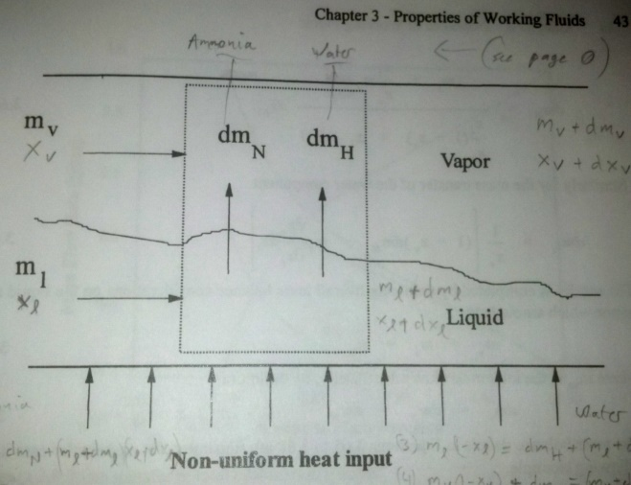

Consider the component mass balances for ammonia in both phases. Two of the variables $(x_{v},x_{l})$ are treated as independent variables, and are both functions of temperature, so then we can solve for the other two variables, $\left(dm_{N}, dm_{H}\right)$. Thus

$$m_{l}x_{l}=dm_{N}+\left(m_{l}+dm_{l}\right)\left(x_{l}+dx_{l}\right) \\ m_{v}x_{v}+dm_{N}=\left(m_{v}+dm_{v}\right)\left(x_{v}+dx_{v}\right)$$

Removing higher order differentials and substituting for $dm_{l}=-dm_{v}$ and $dm_{v}=dm_{N}+dm_{H}$, we have

$$0=dm_{N}+m_{l}dx_{l}-x_{l}\left(dm_{N}+dm_{H}\right) \\ dm_{N}=m_{v}dx_{v}+x_{v}(dm_{N}+dm_{H})$$

Rearranging in matrix form,

$$\left(\begin{matrix}x_{l}-1 & x_{l} \\ 1-x_{v} & -x_{v}\end{matrix}\right)\left(\begin{matrix}dm_{N} \\ dm_{H}\end{matrix}\right)=\left(\begin{matrix}m_{l}dx_{l} \\ m_{v}dx_{v}\end{matrix}\right)$$

Solving,

$$\left(\begin{matrix}dm_{N} \\ dm_{H}\end{matrix}\right)=\frac{1}{-\left(x_{l}-1\right)x_{v}-\left(1-x_{v}\right)x_{l}}\left(\begin{matrix}-x_{v} & {-x}_{l} \\ -(1-x_{v}) & x_{l}-1\end{matrix}\right)\left(\begin{matrix}m_{l}dx_{l} \\ m_{v}dx_{v}\end{matrix}\right)$$ This can be rearranged to match the form in the book by recognizing that $dx_{l}$ and $dx_{v}$ are functions of a single variable $T$. However, the author fails to make the point why this analysis is necessary, because the derivation retains the assumption that temperature is the same on both sides of the interface, therefore the result is the same as the previous section on equilibrium, and the differential equation is unnecessary. Instead of using a control volume, we can solve this using brains:

$$m_{l}x_{l}+m_{v}x_{v}={\left[m_{l}x_{l}+m_{v}x_{v}\right]}_{0} \\ m_{l}\left(1-x_{l}\right)+m_{v}\left(1-x_{v}\right)={\left[m_{l}\left(1-x_{l}\right)+m_{v}\left(1-x_{v}\right)\right]}_{0}$$

Because $(x_{v},x_{l})$ are functions of temperature, we can solve for $\left(m_{l},m_{v}\right)$. Below are the results, so you can believe that they are identical to integration results in figure 3.8. Note the x-axis is *liquid* ammonia mass fraction. So the whole derivation essentially serves to confuse readers, because the authors do not extend its use to non-equilibrium, or not fully-mixed conditions.

